Year 9 Pythagoras and Probability Test

Test 4

Name: ______________________ Class: ______ Time: 50 minutes
/45 marks
Resources: Calculator and one page of notes.
Pythagoras Section:

- Label the hypotenuse on the following triangles: (2 marks)

.
Which is the correct formula for finding the hypotenuse? (1 mark)
a)$a^{2}× b^{2}=c^{2}$
b) $a^{2}+ b^{2}=c^{2}$
d)$c^{2}- b^{2}=a^{2}$

- Which is the correct formula for finding a short side? (1 mark)
a)$a^{2}+ b^{2}=c^{2}$
b)$c^{2}× b^{2}=a^{2}$
d)$c^{2}- b^{2}=a^{2}$

Find the length of the pronumeral in the following triangles. Give your answer correct to two decimal places if required. (9 marks)

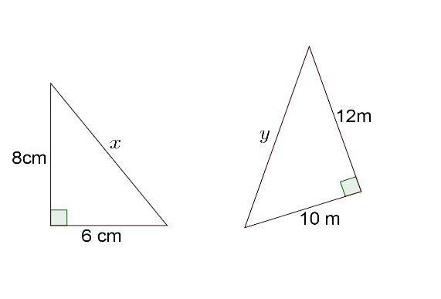
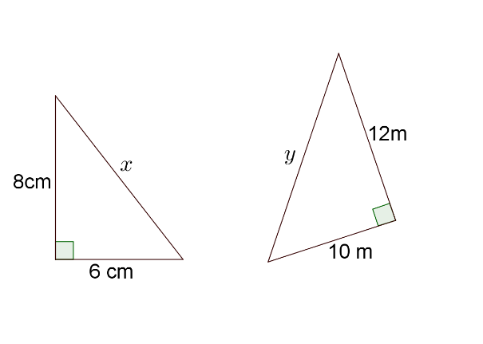

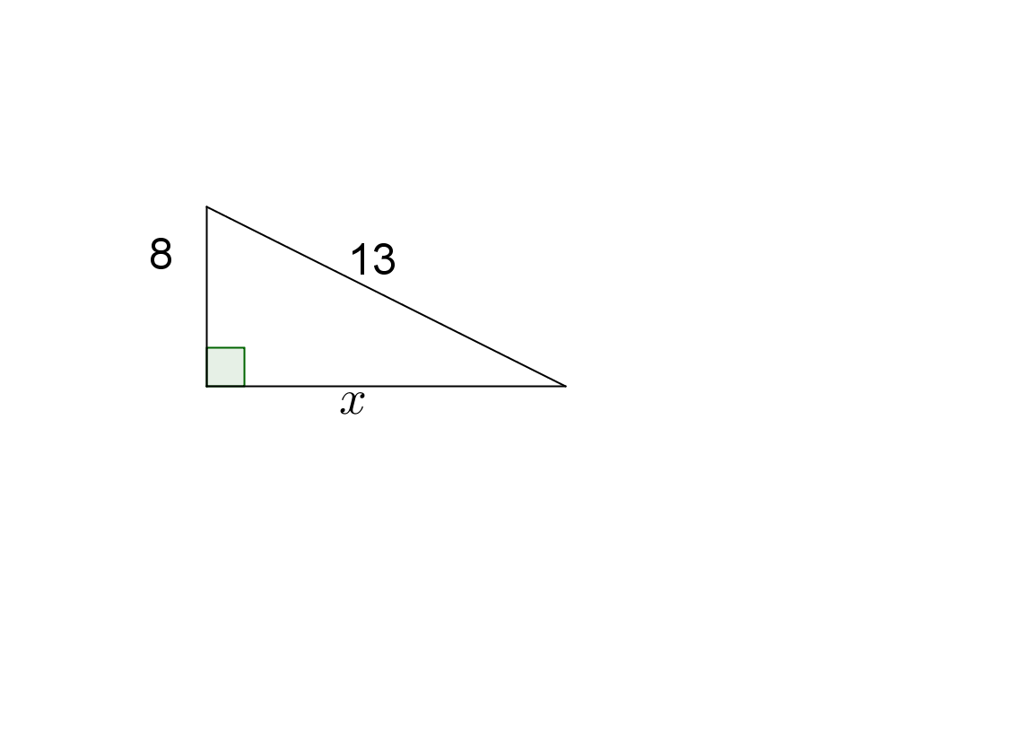

- A 4 m tall ladder reaches 3.7 m up a wall. Find the horizontal distance between the base of the wall and the ladder. Give your answer correct to two decimal places. (hint: Draw a picture)
[4 marks]

- Two poles are located 3.2 m apart. A wire links the tops of the two poles. Find the length of the wire if the poles are 3.8 m and 6 m in height. Give your answer correct to one decimal place.
[3 marks]

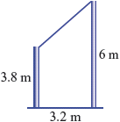

- Are the following right-angled triangles. Justify your answer.
[4 marks]
a. b.
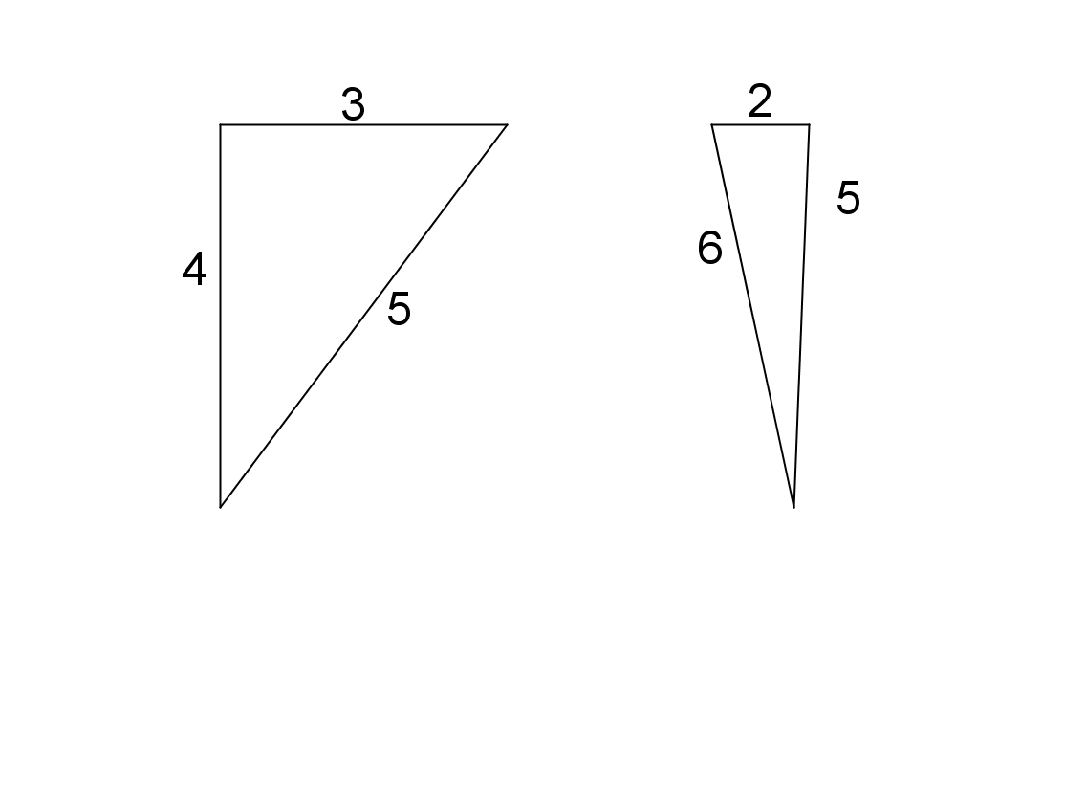


- Consider the following rectangular prism.
[4 marks]
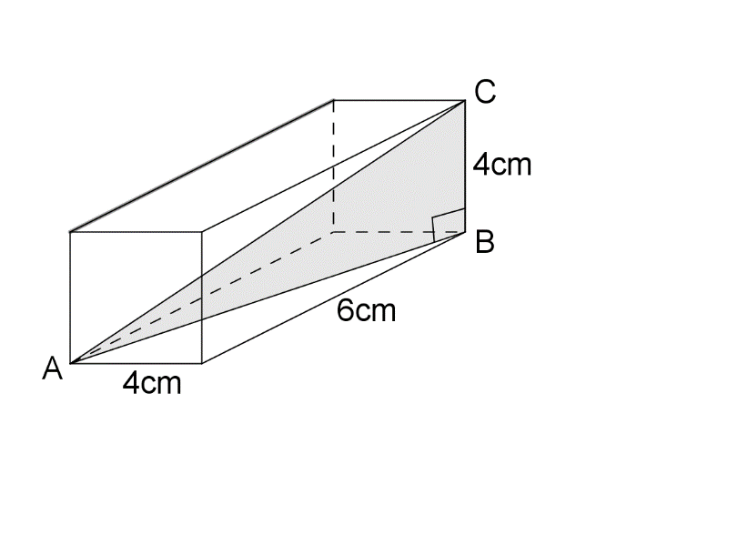

  - Find the length AB as an exact value.

  - Hence, find the length AC. Round your answer to two decimal places.

Probability Section:

- A coin is flipped what is the probability of getting: (2 marks)

- A head =

- 2 tails =

- Ken has 20 marbles in a bag. 12 are green and 8 are red. He selects a marble at random. What is the probability of the following: (4 marks)

Ken selects a green marble: P =

Ken selects a red marble: P =

He selects a white marble: P =

He selects a marble: P =

- Mary is deciding what sports she is going to commit to. She can do gymnastics, dancing or volleyball on Monday and Cross country, Basketball or Soccer on Wednesdays. She doesn’t have enough time to do all the sports and needs a way of exploring her opinions. Create a tree diagram to help Mary see all of her opinions? (6 marks)

- What is the probability she will choose to do dancing and soccer?

- What is the probability of Mary doing at least one ball sport?

- Jackson has the probability of 4/9 of winning his lawn bowls competition and a probability of 2/6 losing the table tennis game. Create a tree diagram with all the outcomes. (5 marks)
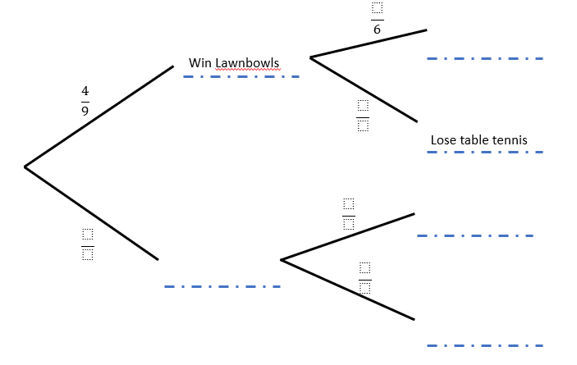

- What is the probability of Jackson losing both lawn bowls and table tennis?

End of test

